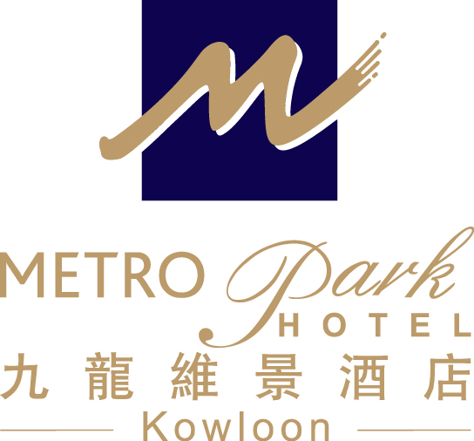
The Open University of Hong Kong
(2008 International Conference on ICT in Teaching and learning)
– Accommodation Reservation Form (06 – 09 July 2008)

To: Anita Hung (Asst. Business Development Manager)

Metropark Hotel Kowloon
Address : 75 Waterloo Road, Kowloon , Hong Kong
Tel : 852 2761 1711 Fax : 852 2760 3603
Direct E-mail: abdm.hkkl@metroparkhotels.com

Name: Mr/Ms/Mrs (First name) (Last name)

Contact No. : (Tel) (Fax) (Email)

Arrival Date: Departure Date:

Room Rate: No. of Room Comfort Single/Double Room at HK$600 nett per room per night

Daily buffet breakfast: Yes No

Special Request: Non-smoking Smoking

Airport Shuttle: Arrival Departure

- Airport transfer by shuttle bus at HK$95.00 per person per way
- Daily buffet breakfast at HK$60.00 net per person on consumption basis
- Free in – room broadband Internet access (unlimited usage)
- Welcome fruit set-up and free local telephone calls
- Free use of Hotel’s swimming pool & fitness room facilities (Open from March to December)

Booking Guaranteed By: Amex Visa Master Diners

Name of card holder: Card No. : Expiry Date:

* The rate is inclusive of 10% service charge and 3% government tax.
- Airport Shuttle Service is provided based on a fixed time schedule. (Please approach B05A counter in HK airport)

Date of Application: Signature:

Notes: 1. The special rate is only applicable to delegates of the above conference.
2. All bookings should be guaranteed by a credit card
3. The deadline for making reservation is on or before 30 June 2008 and the accommodation is subject to availability.
4. In case of ‘No show’ or ‘Late Cancellation’, a penalty charge which is equivalent to 1 night’s room rental will be levied.
5. Cancellation without penalty charge must be reported to Hotel at least 72 hours prior to the scheduled arrival date.

HOTEL USE ONLY

CONFIRMED WAITING LIST NOT CONFIRMED By Date

